|  |
| --- |
| University of Reading |
| Evolutionary Computing |
| Evolutionary Robot Development for Robocode |

|  |
| --- |
| Tom Bedford  5-31-2016 |

Contents

Introduction 2

Development 2

Robot 1 2

Robot 2 2

Robot 3 2

Conclusion 2

References 2

# Introduction

Genetic Algorithms have been a focused area of research for some time. Why, application, results

# Development

Generic Algorithm Flow Chart **Figure .1**

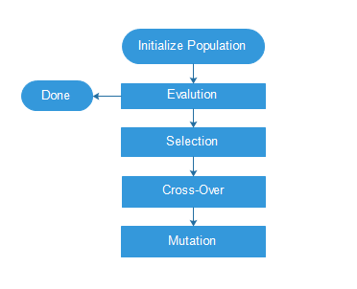

## Ideas:

* Robot that can avoid collisions with walls, other tanks and bullets best.
* Robot that has the most kills at the end of the cycle.
* Robot with the best kills to health remaining comparison.
* Points awarded for finding/scanning another robot.
* Consider changes/adaptions the environment/genotype.
* Roulette selection process for parents to breed children based on fitness level. Probability value assigned to fittest parents.
* N-crossover methods
* Mutation methods

## Robot 1

Design

Results

Conclusion

## Robot 2

Design

Results

Conclusion

## Robot 3

Design

Results

Conclusion

# 

# Conclusion

# References

GA: <https://kunuk.wordpress.com/2010/09/27/genetic-algorithm-example-with-java/>

Genetic Algorithms, available at: <http://techeffigytutorials.blogspot.co.uk/2015/02/the-genetic-algorithm-explained.html>

More GA tutorials, available at: <http://www.ai-junkie.com/ga/intro/gat3.html>

Red and Black binary tree implementation. Available at: <https://gist.github.com/aspyct/3129371>